# **Proposal for Rolsa Technologies: Green Energy Digital Solution**

## **Business Context**

Rolsa has asked for a new and improved digital solution, I am here to provide. They are about saving the environment, they are a green energy company. They install and provide wisdom about Solar panels, EV chargers and smart home systems. Customers need information and they need to schedule meetings/consultations and installations. I’m thinking about creating a website something that’s visually appealing, has useful information for customers yet includes all the features.

I am proposing to create a website that would incorporate the features the client requires and some more. Later down I will be explaining and justifying my proposal.

## **Empathy Map**

|  |  |
| --- | --- |
| **Says**  * "I need more information about solar panels before investing." * "Could I see some case studies from people who've installed these systems?" * "I want to know exactly how much money I'll save over time." * "How do I schedule an installation consultation?" * "Is there a way to track how much carbon I'm actually saving?" | **Thinks**  * “It would be so much easier if I could just book a consultation online.” * “I wonder if solar panels will actually save me money.” * “I wish I could calculate my current carbon footprint and see how much I could reduce it.” * “I don't want to make phone calls, I prefer handling everything online.” |
| **Does**  * Researches multiple websites trying to compare green energy solutions * Gets overwhelmed by technical jargon and gives up * Calls multiple companies for quotes * Delays decisions because of information overload * Struggles to find reliable carbon footprint calculators | **Feels**  * Overwhelmed by the technical information * Confused about the best options for their home * Anxious about making large investments without clear ROI * Proud when thinking about environmental impact * Frustrated by complicated booking processes |

## **User Stories**

|  |  |  |  |
| --- | --- | --- | --- |
| **As a [user]...** | **I want ...** | **So that ...** | **Acceptance Criteria** |
| First-time visitor | To learn about green energy products | I can decide if they're right for my home | The system should display clear navigation, educational content on green energy, and product information with benefits clearly stated |
| Environmentally conscious consumer | To calculate my carbon footprint | I can see how specific products would reduce it | The system should provide an interactive calculator that shows current footprint and projected reductions with different products |
| Prospective customer | To schedule a consultation easily | I don't waste time with phone calls | The system should provide a simple booking interface with available dates/times and confirmation emails |
| Existing customer | To manage my account and view my installation details | I can track energy savings and maintenance schedules | The system should provide a dashboard with installation details, energy savings metrics, and maintenance information |
| Mobile user | To access all features on my smartphone | I can research or book while on the go | The website should be fully responsive with all features working properly on mobile devices |

## **Functional Requirements**

### **Homepage**

The system must display a homepage that consists of a navigation bar, main section and footer. In the main section the website will display a carousel of pictures with links that prompt users to green energy products, the carbon emissions calculator or the consultation booking depending on what the user clicked on.

There are no data inputs on this page.

The Navigation bar will be composed of :

* Home
* About us
* Why Go Green?
* Book Now
* Account

**About Page**

In the about Page the system will show information about the companies story and share with their customers, their mission statement some team profiles and customer testimonials. The reason I am doing this is because it gives more trust for the customer to the brand, thus strengthening it.

It is a static page, so no data inputs required for this page.

### **Why Go Green?**

This page talks about the difference between green energy and fossil fueled energy companies, and why green energy is saving the planet, it also highlights about the different types of products currently on the market and why Rolsa technologies beats their competitors. This page is to primarily provide information and perhaps teach some future potential customers.

This page would consist of a nav bar, main section with some educational content and a footer. The main section will show some images of environmental image for traditional energy vs green energy solutions.

Again a static page, no data requirements for this page.

### **Services We Provide**

The system displays information on:

* Solar Panel installation and maintenance
* Electric vehicle EV charging Stations
* Smart home energy management systems

It will tell what the customers options are but will be short and concise

**The booking system**

The booking system will allow customers to choose from:

* Scheduling a consultation
* Scheduling a installation

The system will have two options either booking a consultation (Having a meeting before the sale) . Or the sale has already been made and the customer has to fill out their personal details , date and timeslot. After the form has been completed the order is supposed to be sent to the database ready for the system to show it on the admin side. The confirmation of booking will be shown to the user.

**User input requirements:**

For Consultations:

* Name
* Email
* Phone
* Address
* Preferred date and time
* Service interest (Solar, EV charging or Smart home)
* Brief description of needs
* How they heard about Rolsa (Good for marketing)
* Property type (House, Apartment, Business)
* Current energy usage (optional)
* Preferred consultation type (In person or virtual)

Note: I assumed that the company does both in person and virtual, (they can charge more in person)

For Installations:

All consultation fields plus:

* The property type
* Access into the property for installation crew (not required)
* Upload property photos for the installation
* Notes the customer wants to include (Property dimensions, Existing equipment, anything additional)

Carbon Footprint Calculator

User can calculate their current carbon footprint based on their lifestyle, home energy, The calculator will show reductions with Rolsa’s Products.

User input requirements:

* Property type (House, Apartment, Business)
* Home size
* Number of people in the property
* Primary home energy source (Electricity, Gas, Oil, Other)
* Transportation(Multiple choice)
* Approximate monthly energy bill (Slider)
* Flights per year? (slider)

The results should be:

Estimated Carbon footprint

How they compare to the average person

Show products

### **Accounts**

New users can register to create an account. Returning users can log in to access their dashboard with installation details, energy savings metrics, and maintenance schedules.

User can manage appointments, view previous consultations, download reports on energy usage, and schedule maintenance.

User input requirements to create an account:

Full name -> Email -> Username -> Password -> Confirm password

User input requirements for the login:

Username -> Password

## **Non-Functional Requirements**

**Security**

It is imperative that the system is secure and robust

* System must be able to handle erroneous data and all inputs
* System must use secure cookies and ask for them too
* System must use SHA256 as it’s the best 1 in my opinion
* System must implement HTTPS for all communication, to make sure its secure.
* API keys must be stored securely to mitigate malicious users from making unnecessary API calls which could violate users data and if it’s a paid API it might come out the companies cost.
* These are all important because user data protection is critical, especially with personal and financial information. SHA256 prevents password theft even if database is compromised.

Maintainability

It is important that after the system has been deployed and tested it can be maintained cost-effectively because the last thing we want to do is be spending more money and time. To do this I will use conventional coding practices, I will ensure that naming conventions are easy and relevant. I will try to stick to standard API formats. I will also make sure to add some comments and a small documentation to allow for future enhancements.

**Website Performance:**

* Page Speed should be ranged anywhere from 2-3 seconds (This is vital because more than this can result in a loss of a potential customer)
* Latency: it should not take more than 200ms for the system to talk to the user.
* The API calls should be optimised to prevent overload

### **Usability -> Accessibility**

The system should be straightforward to use, both for the end-users and the content editors that oversee backend system.

System should be adapted to different user needs and should follow Web Content Accessibility Guidelines (WCAG) 2.1 AA standards. This includes keyboard navigation, screen reader compatibility, and sufficient color contrast.

## **Decomposition**

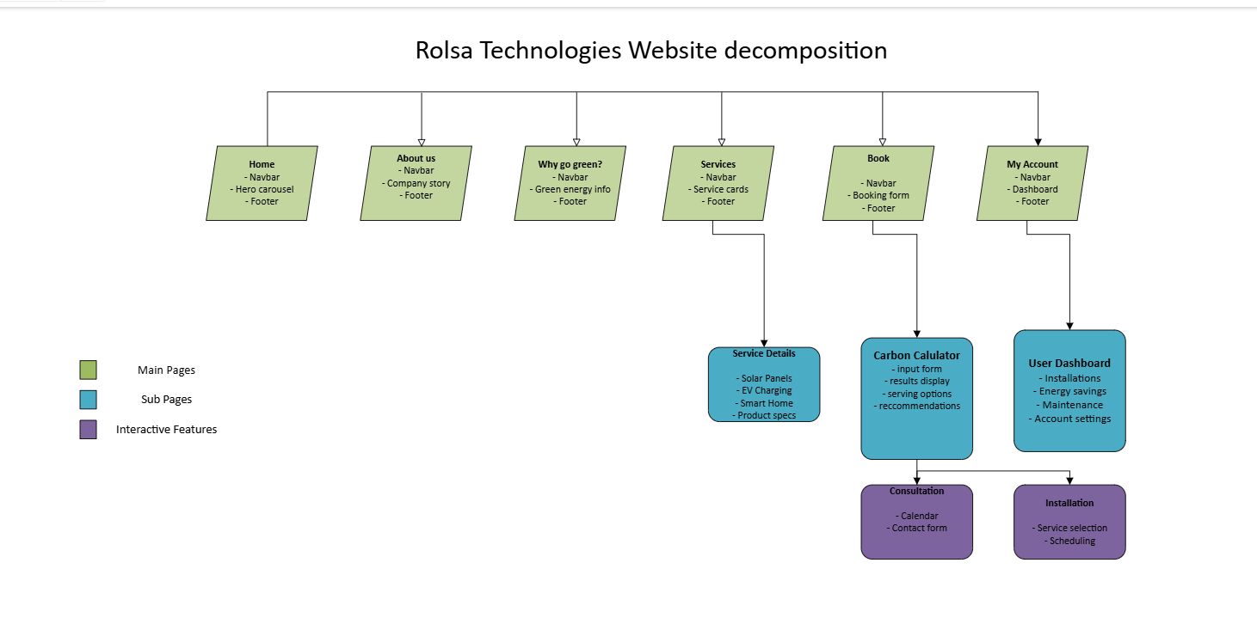

[**Please click here for decomposition for full**](https://ldeutc-my.sharepoint.com/:u:/g/personal/20a_manoj_ldeutc_co_uk/EZYuHGIqUYxDp0LXBTSlG4UBMy2jdfKfSALEz9nLqvt8pA?e=daaxZx)

|  |  |  |  |  |  |
| --- | --- | --- | --- | --- | --- |
| Home | About Us | Why Go Green? | Services | Book | My Account |
| Navigation bar  Carousel as main section  Footer | Navigation bar  Company info  Team profiles  Footer | Navigation bar  Green energy info  Carbon footprint | Navigation bar  Booking form  Carbon calculator  Footer | Navigationbar  Booking form  Carbon calculator  Footer | Navigation bar/  Sign in/ Sign up  Dashboards  Installations  Energy savings  Logout |

## **KPIs**

### **Business KPIs**

#### **Customer Reviews/Trustpilot**

The higher the ranking on third-party review sites like Trustpilot, the better it is for the business. People naturally look for the best options, and social proof is powerful. Should aim for 4.5+ average rating.

#### **Customer Satisfaction Rate**

Helps identify areas for improvement to boost customer experience. Track through post-installation surveys. Industry standard is to maintain 85%+ satisfaction.

#### **Number of Repeat Customers**

Shows Rolsa's ability to maintain customers. Indicates quality of service and customer loyalty. Calculate by dividing repeat customers by total customers and multiply by 100.

Formula:

#### **CO2 Roughly Saved:**

Tracks environmental impact of installed systems. Can be calculated based on system specifications and average usage. Creates powerful marketing metrics.

#### **Revenue Growth Rate**

Assesses Rolsa's financial performance and helps inform business decisions. Calculate monthly and quarterly to identify trends.

### **Website KPIs**

**Page Load Time:**

The time it takes for a page to load is crucial to the company because as I explained earlier, potential customers abandon slow sites, even a few seconds can result in a loss of potential clients.

**Bounce Rate:**

If your page is not appealing or maybe users accidentally click on your website it shows the people who left the page this could be because of multiple reasons such as: no visual appeal, no function, no information relevant to their search etc.

**Traffic by Source:**

It answers the questions from where the users are coming from, was it from google? Social media? Etc. This would help a marketing agency or department to know what they lack and what the strengths are.

**Conversion Rate** :

is when the users pretty much go through your website and do a booking and “converting ” them into an actual customer, this would show how much the website is being used and can use this for our clients to show how much I’ve helped them.

#### **Average Time on Page**

How long users spend engaging with content. This is crucial as it, indicates content relevance and engagement quality. Longer times usually mean better engagement.

## **Overall Summary**

### **A Description of Proposed Solution**

In the above paragraphs I was decomposing, analysing, and setting the requirements for the system. Now I'll sum up the proposal and its main benefits.

The final proposal is an interactive website that includes the following:

Key Features and Benefits of the solution:

* **Inclusive Solution**

I plan on making the solution accessible to lots of people with no knowledge of of technology this means that no customers will be left out. I want to make the design can be understood by all customers and be satisfied.

**Quick, Easy Booking**

Easy Bookings are vital as they are easy to convert a user to a potential customer, This also reduces the amount of phone calls and paperwork because we can get that out of the way.

**Comprehensive Information**

I plan on making the information to be able to be understood by anyone it would give enough information that it wouldn’t be too technical but a perfect balance for anyone to understand. This will include Size of products, how it works, who is going to install, installation working times etc.

**Carbon Calculator**

Interactive tool that helps customers to understand their impact on the world/earth, allowing them to understand how much they are impacting the earth by using lots of carbon emissions this allows for a call to action trying to urge the user to become a customer and get into contact with Rolsa.

**Personalised Experience**

I will try to implement the system to personalise the experience for the customers to track upcoming consultations, installations, impact metrics and manage them.

## Justification

In the above paragraphs I have proposed a digital solution to the client which is an interactive website that meets different users' needs. I have stated both functional and non-functional requirements and provided decomposition. Now I'll justify my proposal.

### **How the Recommended Solution Meets the Needs of the Client**

#### **Inclusion-Driven Solution**

The website will be built with accessibility at its core. Frontend development will use responsive design frameworks such as bootstrap and others. I will follow WCAG guidelines. All colours and contrasts will be checked to ensure readability. Thus I am not leaving out potential customers and can access information and services this widening their market reach and illustrating the social responsibility.

**Efficient way to book Consultations and Installations**

The booking system that I’m going to create make sure that is a very easy process with an intuitive and appealing interface and a confirmation message, The backend database will maintain accurate records of appointments and it will not allow double booking if the same date and timeslot is selected, thus I prevent scheduling conflicts.

#### **All About Our Services Section**

The services section provides comprehensive, easy to understand information about solar panels, EV charging stations, and smart home systems. After researching competitor sites, I've found that technical information presented simply with visual aids increases conversion rates. I am going to try implement the same thing in my solution. This educates potential customers and helps them make informed decisions about which green energy solutions best meet their needs.

#### **Carbon Emissions Calculator**

The calculator tool not only educates users about their environmental impact but creates a powerful sales tool by showing potential savings. Results can be saved to user accounts for future reference. This unique feature differentiates Rolsa from competitors and creates tangible metrics that help customers justify their investment.

One thing I do want to say about the Carbon Emissions Calculator is that because there are a lot of factors that change the overall calculation its going to be hard to take all of that information especially if someone doesn’t fully know all of their answers.

I will show you what impacts the total Carbon Footprint.

Electricity Emissions + Transport Emissions + Fuel Emissions + Food Emissions + Waste Emissions + Water Emissions = Total Carbon Footprint

As you can see this is only a rough estimate too.

### **How Potential Risks Will Be Mitigated**

#### **Random Robots Booking Consultations**

Implementation of CAPTCHA verification on all forms prevents automated spam bookings.

#### **Miscommunications with Customers**

Automated email confirmations with clear details and integrated calendar invites reduce scheduling errors. However since I am doing a prototype I don’t have access to a third party SMTP mail server but when the full system is done we can also implement this.

#### **Booking System Data Loss**

Regular database backups and redundant storage systems protect against data loss. This is what we can do when we have the full system as this would take up too much data.

#### **Carbon Calculator Accuracy**

Regular updates to calculation algorithms using industry-standard metrics ensure reliable results.

#### **Personalised Account - Data Breaches**

Robust security measures including data encryption, secure authentication, and regular security audits protect customer information.

### **Legal Requirements: GDPR, EU Cookie Law**

The website will be fully compliant with:

* General Data Protection Regulation (GDPR)
* EU Cookie Law requiring explicit consent
* Local data protection regulations
* Accessibility standards (WCAG 2.1 AA)

Privacy policies and terms of service will be clearly displayed with appropriate consent mechanisms for data collection.

### **Hardware and Software Requirements**

#### **Server requirements:**

* Cloud-based hosting with scalability options
* SSL certification for secure connections
* Regular backup systems

#### **Development stack:**

* Frontend: HTML5, CSS3, JavaScript (React.js)
* Backend: PHP
* Database: MySQL for flexible data storage
* Payment processing: Integration with major payment gateways

#### **Cashless transactions:**

* Integration with payment processors for consultation deposits
* Secure payment portal with industry-standard encryption
* Support for multiple payment methods (credit/debit cards, digital wallets)

Would you like me to expand on any particular section of this proposal? Or would you like me to refine the writing style further to better match your requirements?